1.SELECT first_name, last_name FROM employees WHERE salary >

( SELECT salary FROM employees WHERE employee_id=163 );

OUTPUT:-

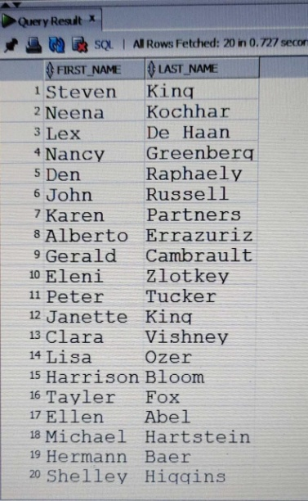

2.SELECT first_name, last_name, salary, department_id

FROM employees WHERE salary IN ( SELECT MIN(salary) FROM employees

GROUP BY department_id);

OUTPUT:-

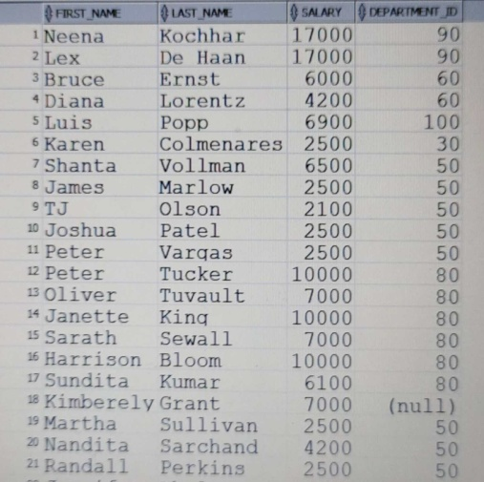

3.SELECT e.department_id, e.first_name, e.job_id , d.department_name

FROM employees e , departments d

WHERE e.department_id = d.department_id

AND d.department_name = 'Finance';

OUTPUT:-

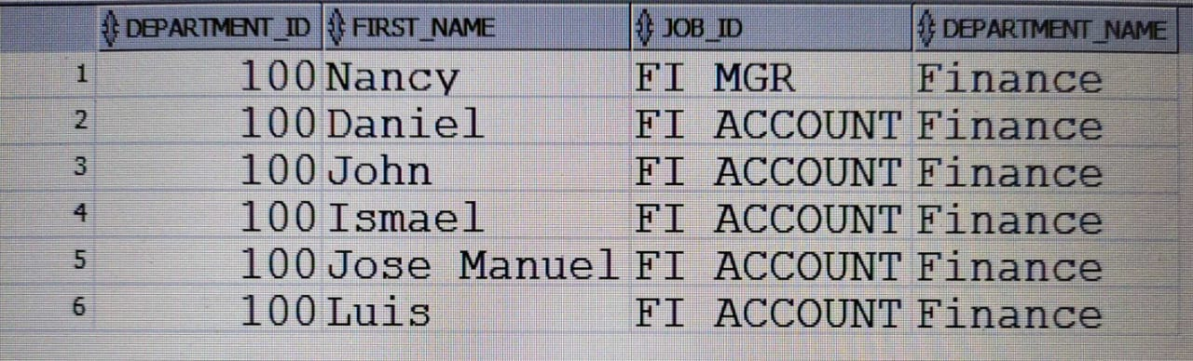

4.select *from employees where employee_id in(select employee_id from employees

where salary=(select max(salary) from employees where salary<

(select max(salary)from employees)))

OUTPUT:-

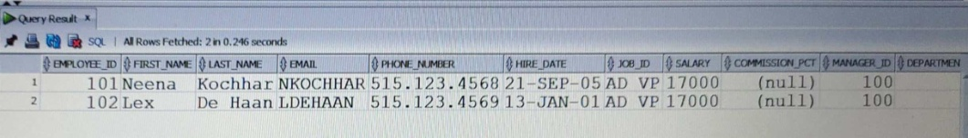

5.SELECT distinct employee_id,first_name,last_name,salary FROM employees WHERE salary>

(SELECT avg(salary)from employees) AND department_id in(select department_id FROM

employees WHERE first_name LIKE '%J');

OUTPUT:-

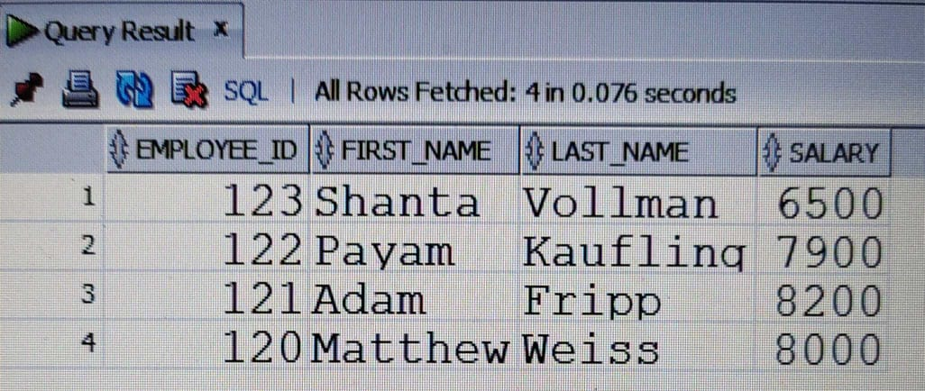

6.select employee_id,first_name,last_name,job_id from employees

where salary < any(select salary from employees where job_id='MK_MAN');

OUTPUT:-

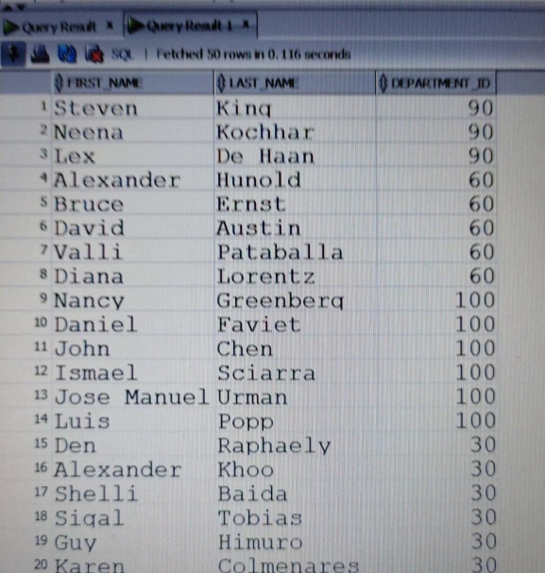

7.select first_name,last_name,department_id from employees

where exists (select salary from employees where salary>3700)

OUTPUT:-

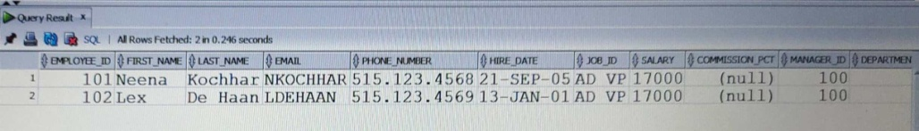

8.SELECT first_name,last_name FROM employees WHERE department_id IN

(SELECT department_id FROM departments WHERE location_id IN

(SELECT location_id FROM locations WHERE country_id IN

(SELECT country_id FROM countries WHERE country_name='United Kingdom')))

OUTPUT:-

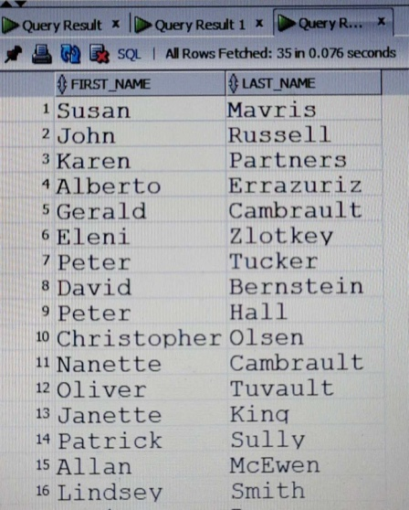

9.select *from employees where employee_id=any

(select manager_id from employees)

OUTPUT:-

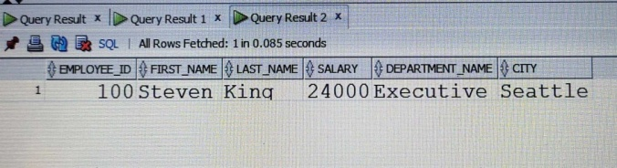

10.select e.employee_id,e.first_name,e.last_name,e.salary,d.department_name,l.city

from employees e,departments d,locations l

where e.salary=(select max(salary)from employees

where hire_date between '01/jan/2002' and '31/dec/2003')

and e.department_id=d.department_id

and d.location_id=l.location_id

OUTPUT:-

